TECHNICAL PROJECT REPORT

# Title of Invention / Project: AUTOMATIC NIGHT LAMP

# Team Members / Inventors:

|  |  |  |  |  |  |
| --- | --- | --- | --- | --- | --- |
| **S.No.** | **Name** | **Department** | **Designation** | **Mobile** | **E-Mail** |
| 1. | Binni Goel | CSE(MC) | Programmer | 6398365664 | [binni1108@gmail.com](mailto:binni1108@gmail.com) |
| 2. | Sarthak Agarwal | CSE(MC) | Leader | 8840068035 | [sarthakagarwal85@gmail.com](mailto:sarthakagarwal85@gmail.com) |
| 3. | Sanya Aggarwal | CSE(MC) | Designer | 8437033340 | [aggarwalsanya27@gmail.com](mailto:aggarwalsanya27@gmail.com) |
| 4. | Khushal Thakur | ECE | Mentor | 9646030764 | [khushal.thakur@cumail.in](mailto:khushal.thakur@cumail.in) |
| 5. | Anshul Sharma | ECE | Mentor | 9478697475 | [anshulsharma.ece@cumail.in](mailto:anshulsharma.ece@cumail.in) |
| 6. | Kiran Jot Singh | ECE | Mentor | 9463909689 | [kiranjotsingh.ece@cumal.in](mailto:kiranjotsingh.ece@cumal.in) |
| 7. | Divneet Singh Kapoor | ECE | Mentor | 9878422653 | [divneet.ece@cumail.in](mailto:divneet.ece@cumail.in) |

Section – 1 (IPR Related)

# Brief Abstract (500 words):

# 

In today’s era there is huge demand and usage of electricity. Electricity is a non renewable resource.. There is a huge problem of electricity in villages. Therefore we need to save electricity and restrict its wastage. It is the moral duty of the people to save electricity like closing the switches whenever the appliances are not required but it is hardly seen that people pay any heed to it. We have one solution to the problem and that is Automatic Night Lamp. It is an intelligent machine making use of Light Dependent Resistor and Bluetooth Module HC-05. In this product the LDR senses the intensity of light. If the intensity of light is within the range of darkness then the lamp will glow but if the intensity of light is not within the range then the lamp will not glow. Moreover the Bluetooth module attached will enable the consumer to turn it off within the range of the Bluetooth when he does not want to use the lamp. This product can be really helpful as it will prevent unnecessary usage of electricity. This will also help the consumer to save his electricity bills to an extent as it will limit the usage of the lamp according to his necessity. We can make the size of the product compact by mapping the arduino code in the product.

Earlier the Night Lamp were either based on LDR or Bluetooth, but this lamp gives the facilities of both **LDR AND BLUETOOTH** which saves more electricity and provide more convenience.

# Existing state-of-the-art and Drawbacks in existing state-of-the-art

(*Brief background of the existing knowledge*)

*GOOGLE PATENT FILE NUMBER:-*

* CN201131069Y
* CN105263245A

|  |  |  |
| --- | --- | --- |
| **S. No.** | **Existing state of art** | **Drawbacks in existing state of art** |
| 1 | The lamp works automatically according to the LDR and Bluetooth. | No other model works on both Bluetooth and LDR in a single model |

# Novel/Additional modifications that you can propose to improve upon drawbacks

*(List down the features)*

* Feature 1: It saves electricity by turning on only when there is less light.
* Feature 2: It works both on Bluetooth as well as LDR
* Feature 3: It provides more convenience.

# Advantages

(*List down the advantages, if each feature is incorporated)*

* Adv 1: It saves electricity as it only works when there is less light.
* Adv 2: It functions on both LDR and Bluetooth.
* Adv 3: It functions automatically and can be switches off using Bluetooth anytime.

# Block Diagram

(*Functional diagram depicting the flow of information in your system. Do not define exact components, only use generic terms. Must include modifications as well.)*

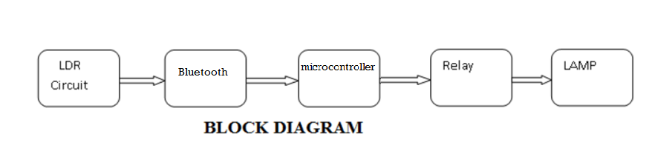

Section – 2 (Real Project)

# Materials

(*List down the Components, Equipment, etc. actually used in the project*)

COMPONENTS QUANTITY PRICE OF THE COMPONENTS

Arduino uno 1 piece 450/-

LDR 1 piece 20/-

Breadboard 1 piece 50/-

Resistors 220Ω 2 piece 5/-

Small LED bulb 1 piece 5/-

LAMP 1 piece 375/-

Bluetooth Module(HC-05) 1 piece 280/-

Relay JQC3F-05VDC-C 1 piece 50/-

Jumper Wires 15 pieces 30/-

# Circuit Diagram

(*Fully functional circuit diagram with exact connections. Can use Fritzing/Proteus*)

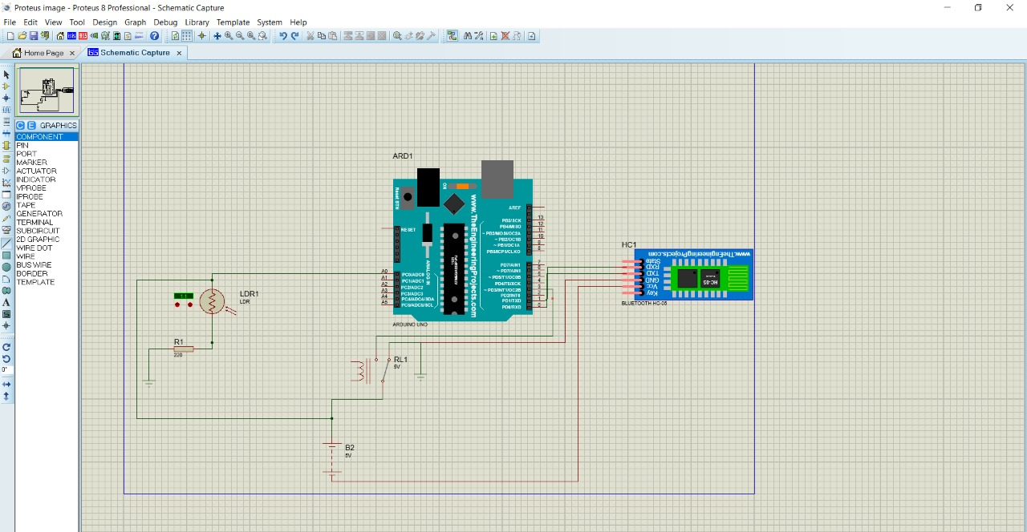

# Steps of Circuit Completion

(*Bifurcate the circuit completion in steps, specify with photographs, leading to final project*)

Step 1: Connect A0 pin of Arduino and 5V Power supply to one end of LDR and the second end to the ground with a resistor of 220Ω

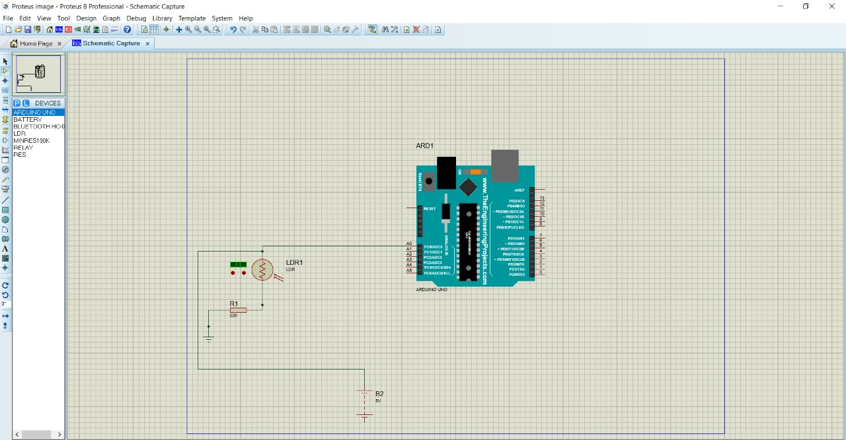

Step 2- Connect Tx and Rx of HC-05 to Rx and Tx of Arduino respectively and ground and vcc to ground and 5V power supply respectively..

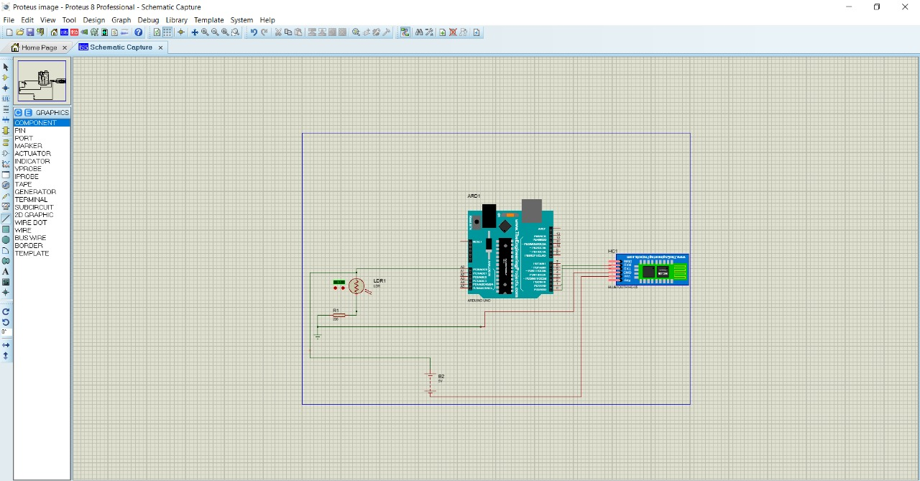

Step 3- Connect D3 Pin of Arduino, 5V power supply and ground to Relay.

# Program Code

(*Link of your Github project*)

https://github.com/sarthakagarwal1999/BEEE-LAB-PROJECT